Making DNA Add
Fraank Guarnieri, Makiko Fliss, and Carter Bancroft
SCIENCE, Vol. 273, pp. 220-223, 1996
Introduction
11+01：
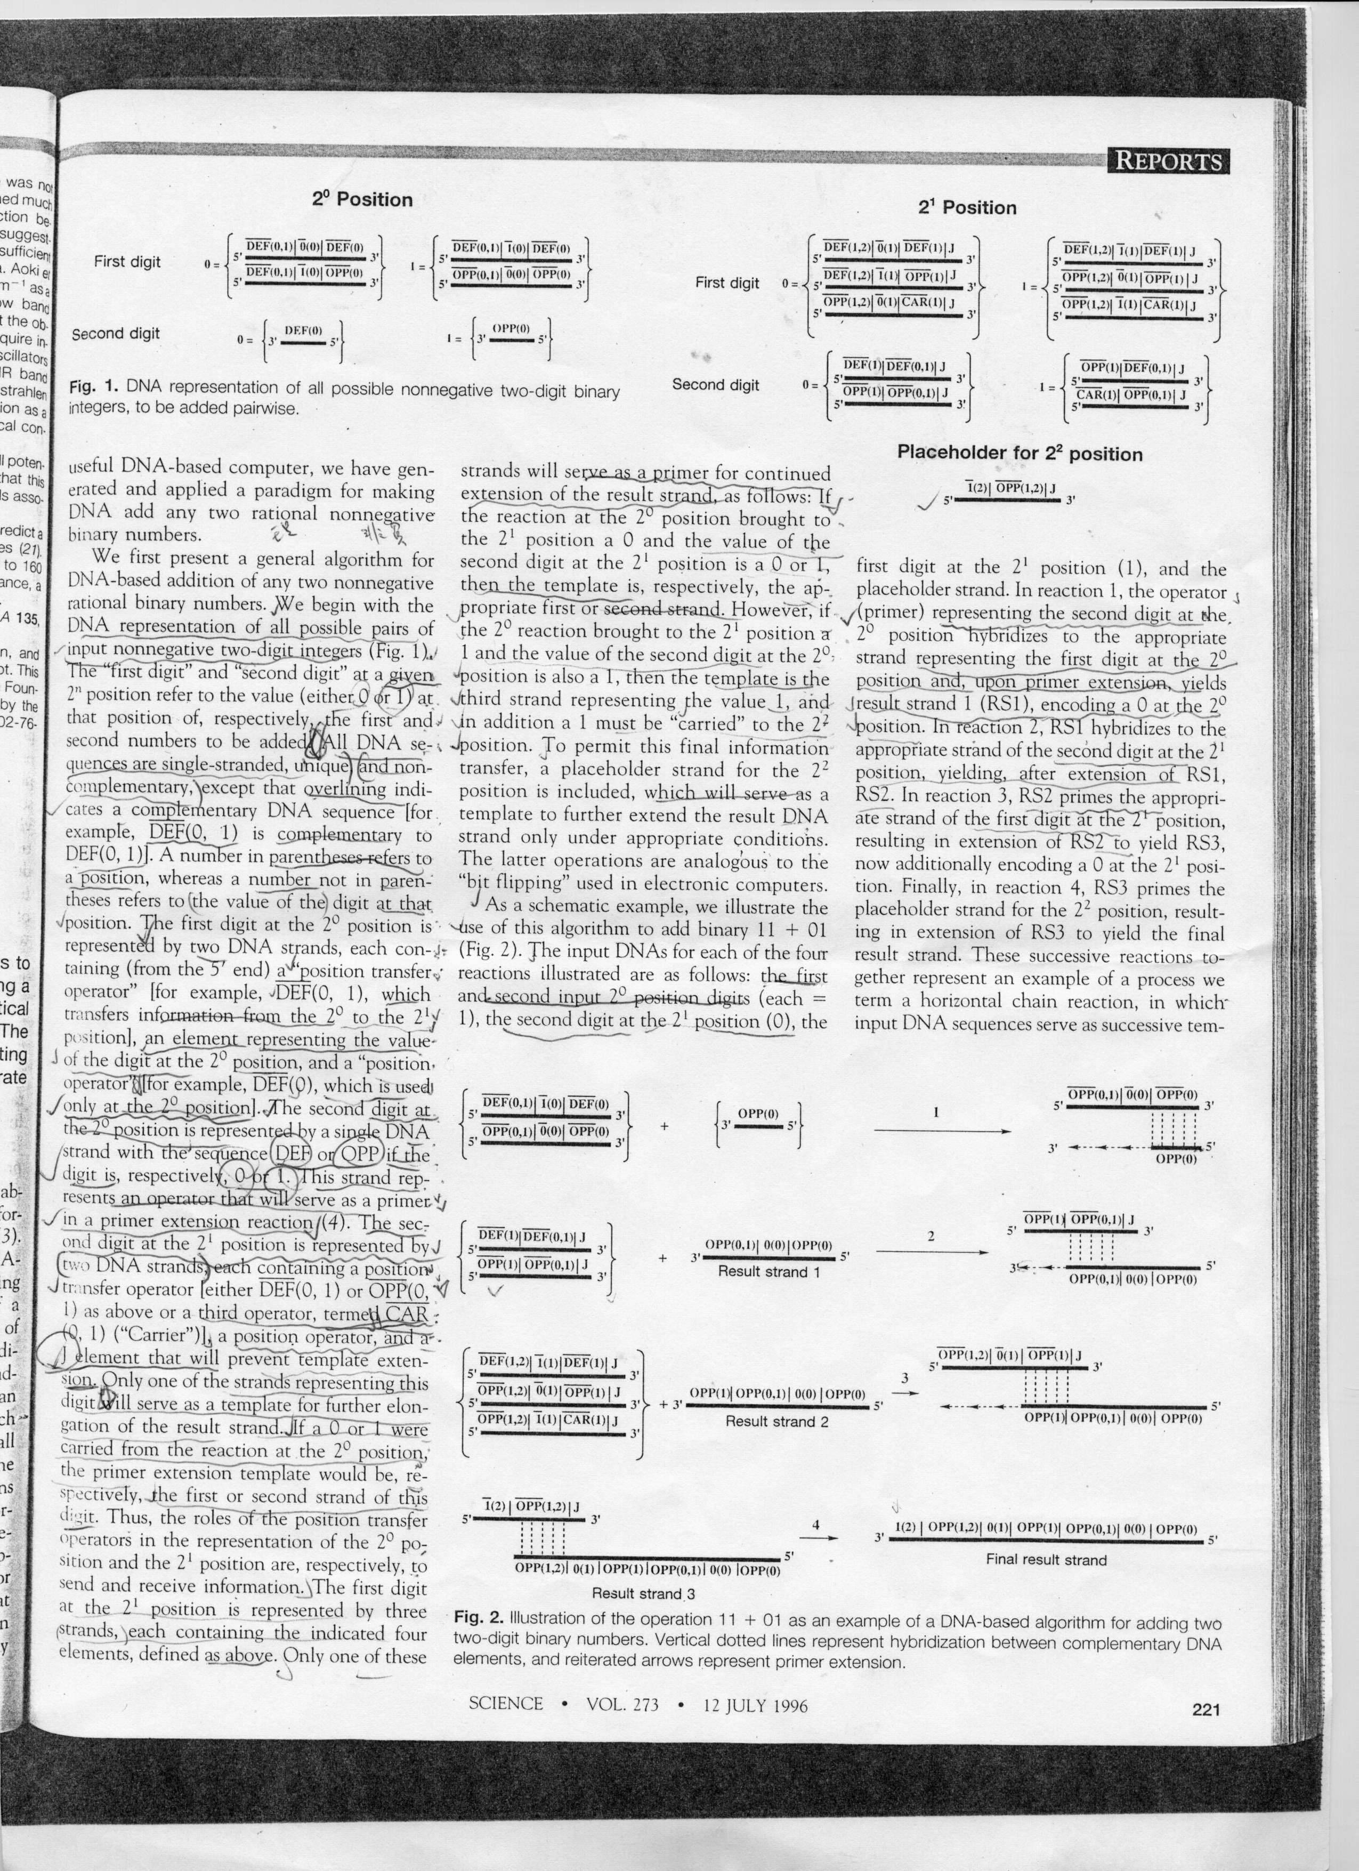

Created by : Hung-Yuan Wang
Date : Dec. 25, 2001

